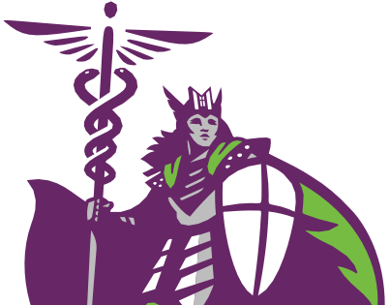

(515) 643-3180

MCHS.edu

928 6th Avenue | Des Moines, Iowa 50309

